Mental Health Service
Cleaning Products for use in Mental Health

Neutral Detergent Wipes
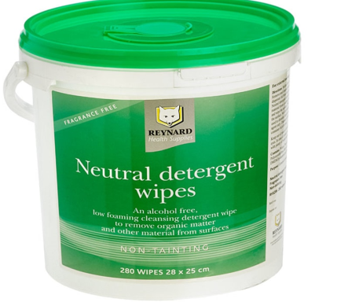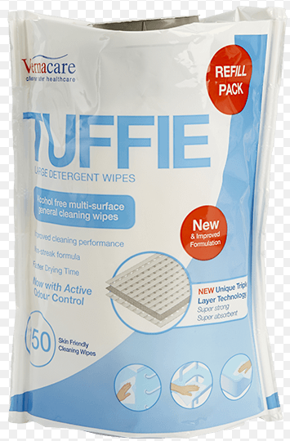 | - Use for general cleaning in office areas and throughout the ward.  - Can be used as the first step of a two-step clean or terminal clean (i.e. clean bulk matter off with this product then wipe with a disinfectant such as Clinell, Viraclean or Sani Cloth Chlor +1000)

Clinell Universal Disinfectant Wipes
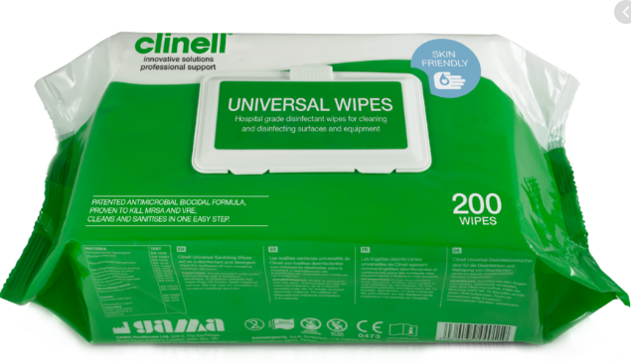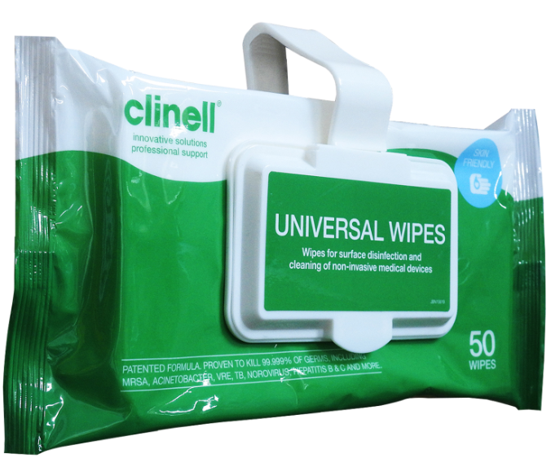 | - Use for surface cleaning and wiping down medical equipment.  - Destroys COVID-19.

Sani Cloth Chlor +1000 - Bleach Wipes
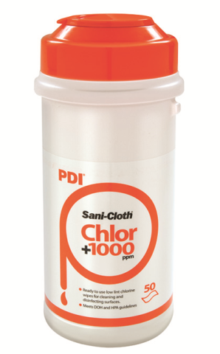 | - Use for disinfecting hard surfaces, fixtures and fittings, e.g. door handles, desks, beds and mattresses.  - Destroys COVID-19.  - Can be harsh on tubing and soft materials such as blood pressure cuffs.

Viraclean Spray and Pour Bottles
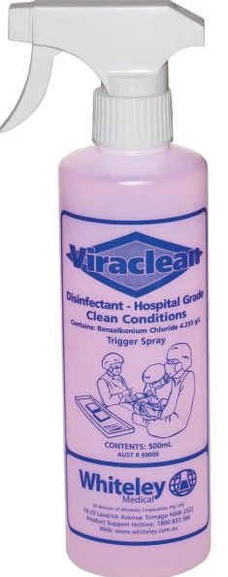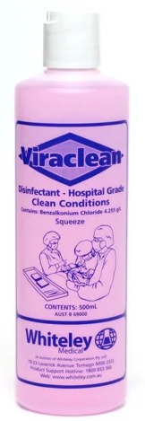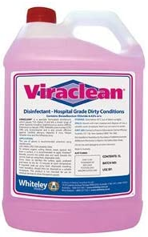 | - Use for disinfecting hard surfaces, fixtures and fittings, e.g. door handles, desks, beds and mattresses.  - Use the pour top where possible.  - Wear goggles when using trigger spray.  - Use neat for disinfecting.  - Destroys COVID-19.

ISOWIPE Alcohol
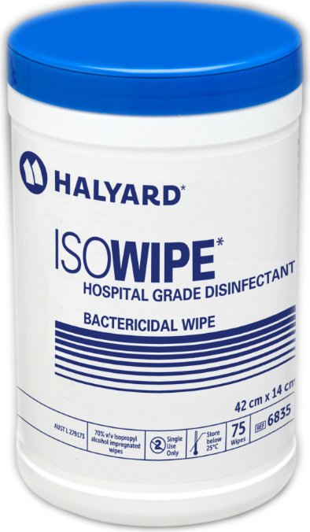 | - Use to clean keyboards, laptops, pens and other metal items.  - You must use a neutral detergent wipe beforehand to ensure that it is effective against viruses.  - Destroys COVID-19 but not good for larger areas or glass and plastic (it can melt and ruin clear plastics).

Don’t forget to:
- Wear gloves for general cleaning and other PPE where there is potential COVID-19 contamination.
- Use friction to ensure any contaminants are removed.
- Make sure the surface you are cleaning is moist from the wipe – use another if necessary so that the chemicals in the wipes can do their work.
- Allow the surface to air dry before you use it.
- Dispose of your gloves appropriately afterward and……….
- WASH YOUR HANDS!

