MHCC NDIS ILC ‘Supporting Community Connection’ CEEP Project - Facilitator/Trainer Guide:
KEY TOPIC 6 – EMPOWERMENT
Slide/s | Time | Key message/s | Resource/s
Prepare four labelled Butcher Paper sheets: Learning Outcomes and Self-advocacy and Self-directed advocacy and Other-directed Advocacy
Familiarise yourself with, and be prepared to speak about the MHCC reimagine. today website which includes knowledge and skills that empower people to navigate the NDIS: https://reimagine.today/

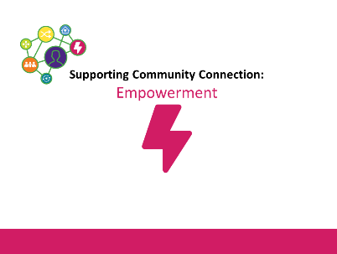  1. | 0-1  1 min | Welcome, etc.  For the next hour we will be thinking and learning about ‘Empowerment’ and being aware that self-direction is a key recovery tool. | PPT in all sections as in the slide column
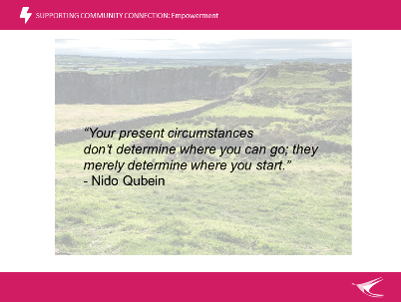  2. | 1-2  1 min | Inspiring quote – present and briefly discuss. May initiate a bit of discussion around our journeys through life.  Link to notions of recovery, hope and self-direction.  Do participants feel this expresses hope?  Is this how you speak/think when helping other people?  You can use language to inspire people.
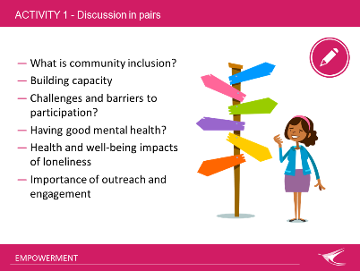  3. | 2-9  7mins | Activity 1: Pairs discussion  Let’s spend a moment reflecting on our own decision-making.  In pairs have a chat about these three questions for 5 minutes:  What decisions have you made so far today? Make a list on A4 paper.  We make LOTS, mostly SMALL decisions. Examples to consider:  - What to wear; what to eat (simple and small)  - How to get to your destination (small but perhaps complex)  Give time for participants to write their decisions  Encourage participants to write as many as they can with the offer of a prize such as a copy of the Recovery Oriented Language Guide  Then ask them to think about  What influenced these decisions?  - WHO or WHAT did you consider? Internal/External  eg family, colleagues, health, time, traffic, $ values  What would it be like if someone else made these decisions for you?  - Were decisions made alone or with support?  Activity first, followed by discussion  - We make countless decisions each day (research says 35,000).  - Some are thought through; others are more immediate and instinctive.  - Do you sometimes make a bad decision or mistake? What happens then? (We learn from it)  - Our decisions are a reflection and expression of who we are, our relationships, achievements and hopes for the future.  - Through making decisions we also learn about ourselves, others and the world.  - It is part of what being a person means and is recognised as a human right.  - At times, we all involve others in our decisions  - We all have the ability to make decisions, but some may not have had the opportunity to make many decisions and so may have limited skills. By giving opportunities and support we can help them build those skills.  Learning will focus on how we can enhance the support we provide. | A4 paper for each pair,  Blu Tac
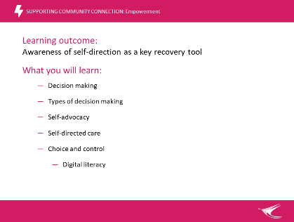  4. | 9-11  2mins | - Decision making  - Types of decision making  - Independent decision making  - Supported decision making  - Shared decision making  - Substitute decision making  - Self-advocacy  - Self-directed care  - Choice and control  - Digital literacy  Is there anything ese you would like from this session? | Pre-labelled  Butcher Paper  Learning Outcomes
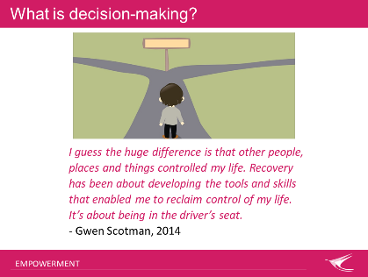  5. | 11-13  2 min | Gwen Scotman is a Consumer Activist  What is decision-making?  As you noted in the previous activity:  - Some decisions are small, and some are big  - Some are small but complex – provide some practical examples such as turning right at a busy intersection. This is only one aspect of driving a car.  - Some are big but simple – ask for examples from participants  - Some decisions have multiple elements that are a combination of these  Big decisions can be simple (if you know your preferred option and have all the information, and it can be easy to carry out) or big decisions can be more complex (e.g. where to live? What to do with your life?)
6.  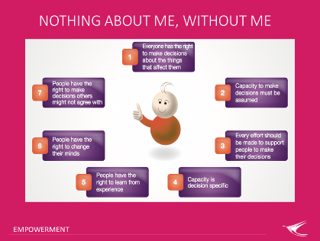 | 13-16  3mins | Department of Human Services Victoria: Seven decision-making principles  1. Everyone has the right to make decisions about the things that affect them  2. Capacity to make decisions must be assumed  3. Every effort should be made to support people to make their decisions  4. Capacity is decision specific  5. People have the right to learn from experience  6. People have the right to change their minds  7. People have the right to make decision others might not agree with  Elaborate on all the points above and relate them to your own lives. Many of the above points are recommended as part of good parenting guides.  In Summary: Nothing about me, without me  Don’t make any decisions about me without me. I am the boss of my life.
7.  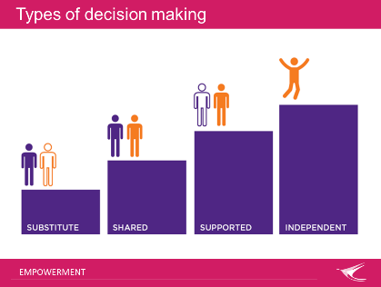 | 16-17  1 min  17-18  1 min  18-23  5 min  23-24  1 min  24-25  1min | Keep this slide visible while discussing each type in detail  Name each type and pointing to the figures, briefly explain the increasing control and independence of the person in each type. Now detail to follow.  Independent decision-making –  A person does not need assistance to make decisions.  Person makes the decision but may choose to talk to others for support or advice at times. May do some research to inform their choice.  This is probably like all the decisions you wrote in the start activity – relate to these.  Supported decision-making (SDM)  Discussion first:  (Use butcher paper to mind map responses)  - What do you know about Supported Decision Making (SDM)?  - What is your experience of Supported Decision Making (SDM)?  Record some responses on butcher paper and be sure to include:  SDM - is a process of assisting a person with disability to make their own decisions, so that they can:  - develop and pursue their own goals  - make choices about their life  - exercise control over the things that are important to them  - build skills and self-esteem  Possible responses:  - A process of ASSISTING – not DOING FOR or cutting them adrift without appropriate support.  - Providing the right BALANCE of SUPPORT to make informed decisions.  - PERSON IS AT THE CENTRE  - SDM assists person to make their OWN DECISIONS – identifying what the person wants, not what others think is in their best interests.  - Supporter is neutral and does not demonstrate a preference for any option.  - Let person know you are there as support  - Allow person to make mistakes  - Builds capacity of the person  - Ask permission to offer any level of help  Possibly draw the following diagram on white board to illustrate the outcome  Liability  Illness  Knowledge & Hope  Supported decision making  Asset  Lived Experience  Diagram highlights the outcome  Support a person to become empowered and to:  - Develop and pursue their own goals  - Make choices in their life  - Exercise control over things that are important  - Build skills and self-esteem and confidence  Shared decision-making –  a person seeks and integrates the advice or opinions of a trusted support person. (Family, friend or worker etc.)  The person still owns and has control of the decision-making.  This support relationship can be formal or informal.  Person is assisted to communicate  Substitute decision-making /proxy – Decisions are made on behalf of the person.  The person does not retain control of the decision making.  Person considered to lack decision-making capacity and another person carries out the decision-making.  Appointed private guardian (family or friend) or Public Guardian can make medical or lifestyle decisions.  Decisions should still be driven by the ‘will and preference’ of the person (their known preferences, desires and expressed wishes) and not what others believe are their ‘best interests’.  Should only be used as a last resort. | Butcher paper
8.  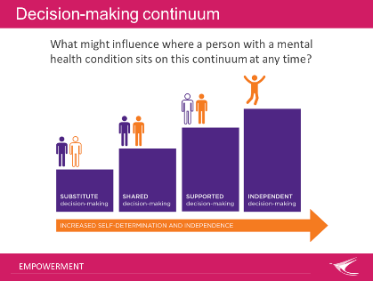 | 25-30  5mins | Decision-making continuum  Where you sit on the continuum can vary depending on the complexity of the decision to be made, support available, our individual preferences, experiences and ability.  - The support a person needs is influenced by many factors and can be shown on a continuum with increasing self-determination and independence.  - Talk through each type on the continuum  - Our ability to make decisions depends on the complexity of the decision to be made, support available, our own preferences, experiences and ability.  - Decision making is a dynamic process and related to the specific decision and current circumstances.  Discussion – white board  - What are some things that might influence where a person sits on the decision-making continuum at any time?  - Why might a person with a mental health condition end up at the substitute decision-making end?  - Could a person benefit from using more than one decision-making approach?  Decision Making is an advanced cognitive skill that requires concentration, memory, planning, problem-solving and considering the consequences of actions.  Many things affect our decision-making capacity – whoever we are - we may have a mental health condition that affects how we function day to day.  It is common for a person with a mental health condition to experience some level of cognitive difficulty.  - Side effects of MH treatment  - Episodic nature of some MH conditions  - Effects of long-term substance abuse/misuse  - Stress and lived experience of trauma  - Physical health issues, injury, social isolation  This can affect a person’s ability to perform daily activities, and can also influence how workers, family and others perceive and judge their skills, abilities and interest in participating in activities, setting goals and making their own decisions.  A person may also internalise the beliefs of others and lack belief in their own ability to make decisions. Stigma, discrimination, loss of confidence and self-stigma.
9.  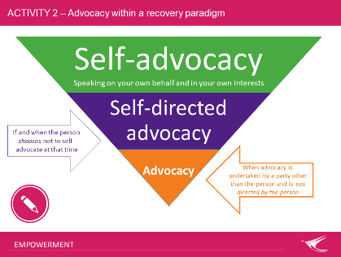 | 30-40  10mins | Advocacy –  Is the act of representing, pleading or negotiating on behalf of yourself or another person to promote, protect and defend your rights, welfare, wellbeing, justice and quality of life.  Activity – group discussion  Ask for examples of ways advocates can help another person: Then record these on WB. Some examples are:  - Write letters on your behalf or write them with you or help you to learn to write letters  - Call someone for you, or sit with you while you ring or practice so you can ring them  - Speak on your behalf, or sit with you while you speak up or practice with you so you can speak up for yourself  - Attend meetings with you or help you practice and rehearse for meetings, so you are more confident  - Teach you to advocate for yourself and develop new skills  Models of advocacy  There are many models of advocacy and it is important to understand these and recognise the values and practices that underpin each model.  Give an overview of three different models of advocacy and a brief description of each.  Self-advocacy – when a person speaks up and can communicate and negotiate for their needs wants and rights. It involves representing yourself and your best interests. This includes asserting and negotiating in your own interests, for example: speaking up for yourself about your rights, responsibilities and interests; asking for what you want and need; and speaking up and managing your own affairs and making your own decisions.  Self-directed advocacy – if and when the person chooses not to self-advocate at that time. It is directing another person (worker, advocate, family member) not only to speak on your behalf, but also in regard to the content and intent of the advocacy messages and practices.  Advocacy – undertaken by a party other than the person and is not directed by the person. A person is unable to advocate for themselves so may require a lawyer for example  Activity 2: Models of advocacy - allocate the examples from the White Board to each model on butcher paper  This draws from the group: When might each model be useful?  Now ask: What are the strengths and weaknesses of each model? | WB = white board  Models of Advocacy:  Three pre-labelled Butcher Paper sheets:  Self-advocacy  Self-Directed Advocacy  Other-Directed Advocacy
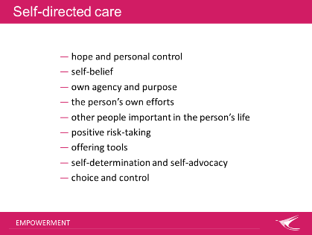  10. | 40-42  2min | Self-directed care is about:  - supporting people to develop a sense of hope and personal control  - believing in the person, even when they might not believe in themselves  - supporting people to develop a sense of their own agency and purpose  - acknowledging the significance of the person’s own efforts in their recovery  - recognising and supporting the roles of other people, and other things important in the person’s life, outside the realm of mental health service delivery  - supporting and understanding the importance of positive risk-taking to the recovery process  offering tools (such as skills, knowledge, expertise, techniques, resources and information) that the person can then choose to use
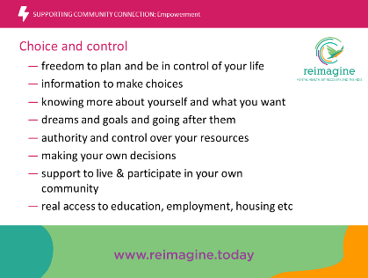  11. | 42-48  2min | Self-directed care and self-advocacy both work towards choice and control:  - having freedom to plan and be in control of your life  - having information to make choices  - knowing more about yourself and what you want  - having dreams and goals and going after them  - having authority and control over your resources  - making your own decisions  - having support to live and participate in your own community  - having opportunities and access to education, employment, housing etc  No-one else making decisions when they don’t understand me. Nothing about me without me.  Key advice: Anyone can help someone to ‘get through the day’. You don’t have to be a guru. Just be there, listen.  For more information about self-direction and choice and control as key recovery tools a useful resource is the reimagine today website https://reimagine.today/
12.  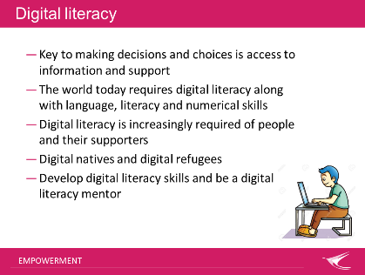 | 48-49  1min | Digital literacy  - Key to making decisions and choices is access to information and support  - The world today requires digital literacy along with language, literacy and numerical skills  - Digital literacy is increasingly required of people and their supporters  - Digital natives and digital refugees  - Develop digital literacy skills and be a digital literacy mentor  Community inclusion means having access the information required to make decisions. People need to develop digital literacy to access information.
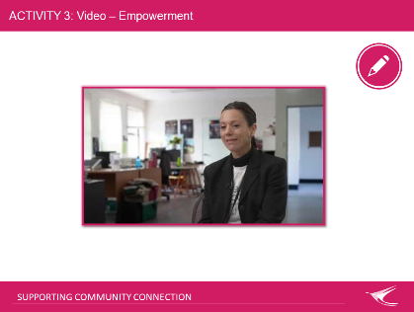  13. | 49-59  10 min | Activity 3  Show and discuss video. For discussion: How are the experiences of Community Workers and other paid/unpaid supporters in this video related to the awareness of people being in control of their lives with choice and decision making? | Audio speakers (as required)  Video embedded in PPT  Back-up internet/USB access to videos
14.  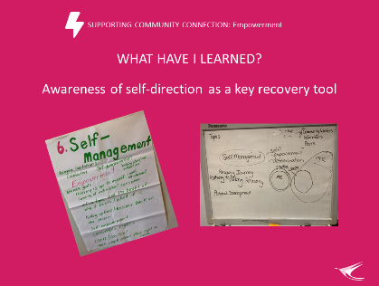 | 59-60  1min | Revisit whether the learning outcome for this topic was achieved: Awareness of self-direction as a key recovery tool? (and also see slide 4).  Remind learners that we started off by:  Exploring what decisions, they have made today and  What influenced these decisions? and  What would it be like if someone else made these decisions for you?  Explore if the topic content supported achieving the learning outcome and other learning topic expectations of this session that were put on Butchers Paper earlier. | Revisit Butchers Paper from beginning of session:  Learning Outcomes
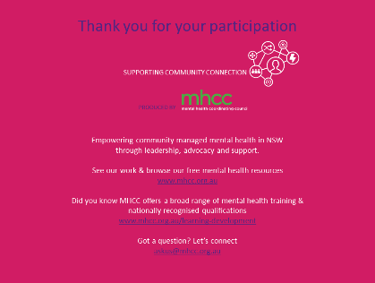  15. |  | Acknowledge MHCC’s development of the learning resource and encourage others to learn more about who MHCC is and what they do:  - Peak body for the community managed mental health sector in NSW  Registered training organisation.

