MHCC NDIS ILC ‘Supporting Community Connection’ CEEP Project - Facilitator/Trainer Guide:
KEY TOPIC 4 – EMBRACING CHANGE

Slide/s | Time | Key message/s | Resource/s
Prepare four labelled Butcher Paper/s – Acronyms and The NDIS ILC, Learning Expectations and Changes
Familiarise yourself with, and be prepared to speak about: Strengthening Information, Linkages and Capacity-building: A National Strategy Towards 2022 (2018): https://www.mhcc.org.au/wp-content/uploads/2019/09/Strengthening-ILC-National-Strategy-towards-2020.pdf

1.  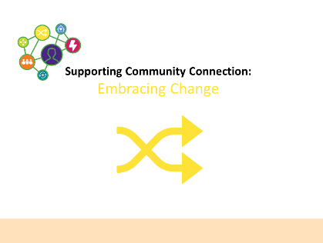 | 0 – 1 min  (1 min) | For the next hour we will be thinking and learning about the importance of being aware of new approaches and practices in the mental health reform and National Disability Insurance Scheme (NDIS) Information, Linkages and Capacity-building (ILC) implementation environments.  Note: State that this topic does not look at NDIS access for people living with psychosocial disability. For that information visit the Mental Health Coordinating Council (MHCC) website reimagine.today. reimagine-today is about people living with mental health challenges accessing and navigating the NDIS.  Acknowledge that there are issues for people living with mental health challenges in accessing and navigating the NDIS and that we will be looking at solutions for these problems. | PPT in all sections as in the slide column  PPT handout at 3 slides per page and note taking lines.
2.  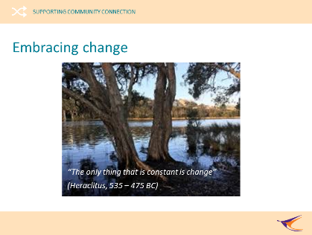 | 1 – 3 min  (2 min) | Reflection  Inspiring quote – present and briefly discuss: “The only thing that is constant is change” (Heraclitus, 535 – 475 BC).  State that change is inevitable. It is like a river flowing downstream, following the law of gravity. When you resist it, it feels like trying to row upstream during a flood.  When you accept change, and embrace it, is like easily flowing downstream.  Link to notions of the need to have a greater awareness of new approaches and practices in the mental health and NDIS and ILC environment (i.e., topic learning outcome introduced in Slide 4).  Talk about how challenging change can be and how great it is that people are here to talk about the human services change environment that all of us are trying our best to work with and learn more about.
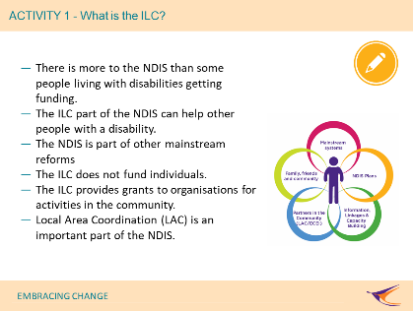  3. | 3 – 10 min  (7 min) | ACTIVITY 1: What is the ILC?  Note: Do not show this slide before doing the activity. Activity 1 is used to assess people’s prior knowledge of the ILC part of the NDIS.  Note that you will have already used three acronyms in introducing this topic. Explain that acronyms are letters used instead of using the full name of things. Can people remember the three acronyms that have been used (NDIS, ILC and MHCC). Write these on the Butcher’s paper and ask what they mean. Explain that we will be adding to the list as other acronyms we use them during this topic.  Explain that the National Disability Insurance Scheme (NDIS) is about more than people just receiving funded packages of supports and services. Ask if anyone is aware of the Information, Linkages and Capacity-building part of the NDIS and note responses on Butcher’s Paper (it may be that people are not aware and this knowledge is not a learning outcome for this course).  Reveal slide and explain that:  - The Information, Linkages and Capacity-building (ILC) part of the NDIS that helps all people with disability and other diversities be included in their community. Other diversities include: ATSI, CALD. GLBTIQA+ and rural/remote (ADD ACRONYMS TO THE LIST)  - The NDIS is part of the National Disability Strategy and is also occurring in a MH reform environment.  - The ILC part of the NDIS does not fund individuals.  - The ILC provides grants to organisations to carry out activities in the community that benefit all Australians with disability and their carers, families & kinship groups.  - Local Area Coordination (LAC) is an important part of the NDIS (ADD ACRONYM TO THE LIST).  Refer people to the topic additional resource ‘ILC Strategy’ and encourage them to learn more about, and engage with, ILC activities in their local community. | Butchers Paper – Acronyms  Markers  Blu Tac  Butchers Paper – The NDIS ILC
4.  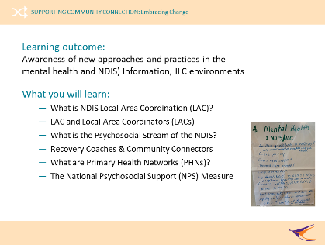 |  | What will I learn?  Introduce learning topic and learning outcome: Awareness of new approaches and practices in the mental health, NDIS and ILC environments.  Briefly reference what you will learn and then ask if people have other expectations of this session. Document other expectations on Butchers Paper (this will also be revisited at the end of the topic).  Note that PHN (Primary Health Network) and NPS (National Psychosocial Support) are new acronyms and ADD THESE TO THE ‘Acronyms’ LIST ON THE BUTCHER’S PAPER.  Ask if people have other expectations of this topic, other than perhaps learning a lot of new acronyms, and list these on the Butcher’s Paper. ‘Other Expectations’ will be revisited at the end of the topic. | Butchers Paper – Other Expectations  Markers  Blu Tac  Butchers Paper – Acronyms
5.  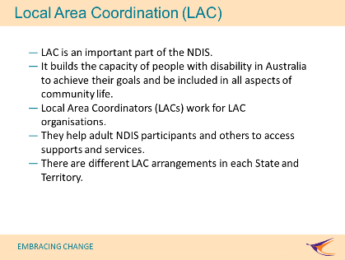 | 12 – 15 min  (3 min) | Local Area Coordination (LAC)  People sometimes call Local Area Coordination (LAC) the ‘backbone of the NDIS’. This is because in each State and Territory the NDIS funds community organisations to help people living with disability to access supports and services whether or not they have NDIS funding.  Explain that:  - The LAC is an important part of the NDIS Information, Linkages and Capacity-building (ILC) initiative.  - It aims to build the capacity of people with disability in Australia to achieve their goals and for them to be included in all aspects of community life.  - Local Area Coordinators (LACs) work for LAC organisations.  - They help adult NDIS participants and others to access supports and services.  - There are different LAC arrangements in each State and Territory.  Ask ‘Who is your local LAC’? Explain that when you know who the LAC service in an area is you can begin to build, and encourage others to build, working relationships with Local Area Coordinators (LACs).
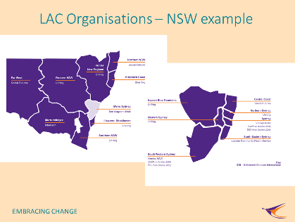  6. | 15 – 18 min  (3 mins) | LAC Organisations – a NSW example  Direct people to the slide showing an example of NSW LAC organisations. People in other States and Territories may want to replace this slide with information about LAC organisations in their communities.  Ask if anyone has worked with a LAC organisation or LACs in their community? If they wish to provide it then what was the name of the LAC organisation? What did they do to help?  Explain that just like the NDIS, LAC organisations and their workers (LACs), are new and finding their way through the changes happening to. Encourage people to build relationships and support one another through these changes.
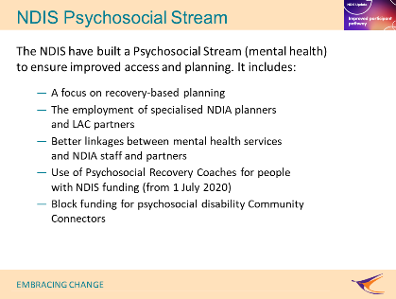  7. | 18 - 23 min  (5 min) | The NDIS Psychosocial Stream  The NDIS are building a Psychosocial Stream to help ensure greater consistency in access and planning for people with living with psychosocial disability related to a mental health condition. At the end of March 2020 there were more than 38,000 people in Australia living with psychosocial disability with NDIS funding (NDIS Quarterly Report). When the NDIS is rolled out 64,000 people living with psychosocial disability will have NDIS funding.  The ‘Psychosocial Stream’ will help to achieve this. It includes:  - A focus on recovery-based planning and episodic needs  - The employment of specialised National Disability Insurance Agency (NDIA; ANOTHER ACRONYM FOR THE LIST) planners and Local Area Coordinators (LACs) to support NDIS access  - Better linkages between mental health services, and NDIA staff and LAC partners  - Use of Psychosocial Recovery Coaches to help people access and navigate NDIS funding (this is a new funded support item from 1 July 2020), and,  - Block funding for psychosocial disability Community Connectors (information about this is forthcoming). | Butchers Paper – Acronyms  Markers
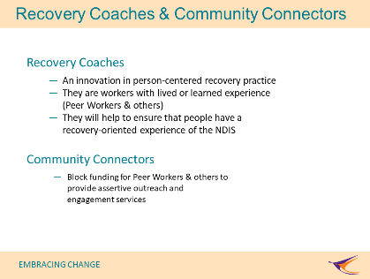  8. | 23 – 28 min  (5 mins) | Recovery Coaches and Community Connectors  As at May 2020 will still need to learn how ‘Psychosocial Recovery Coaches’ and ‘Community Connectors’ will work. This slide and topic content may need to be updates as information becomes available.  Recovery Coaches  - An innovation in person-centred recovery practice. Recovery coaching has emerged as an innovative application of person-centred recovery principles to support people with psychosocial disability to live a full and contributing life  - They are workers with lived or learned experience (Peer Workers and others). Psychosocial recovery coaches with lived experience utilise personal lived experience to support people in recovery.  - They will help to ensure that people have a recovery-oriented experience of the NDIS. This support complements other forms of support and will motivate participants, facilitate self-management, enhance informed choice and control, and enable social and economic participation. They will support participants to foster hope and build capacity and resilience through strong and respectful relationships. This support will work collaboratively with participants, families and other services to identify, plan, design and coordinate supports.  Community Connectors  Less is known about this new service. It is thought to be block funding for Peer Workers & others to provide assertive outreach and engagement services to people living with mental health challenges to help them access the NDIS and/or other supports and services.
9.  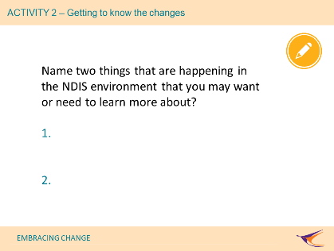 | 28 – 34 min  (6 min) | ACTIVITY 2 – Getting to know the changes  Ask people to name two things that are happening in the NDIS environment that they, or others, may want or need to learn more about?  Some examples of responses would be: the National Disability Insurance Scheme (NDIS), the Information, Linkages and Capacity-building (ILC) part of the NDIS, Local Area Coordination (LAC) organisations in my area, getting to know Local Area Coordinators (LACs) in my area (workers), better understanding what LACs do, learning more about the ‘Psychosocial Stream’ of the NDIS, ;earning more about Psychosocial Recovery Coaches, learning more about Community Connectors.  People may identify wanting to know more about Primary Health Networks (PHNs) and National Psychosocial Support (NPS) services and that is great as these are discussed next.
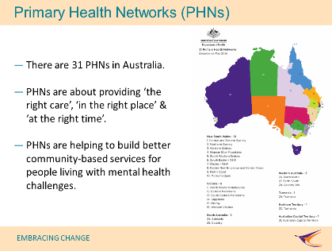  10. | 34 – 37  (3 mins) | Primary Health Networks (PHNs)  There are 31 PHNs in Australia. PHNs work with GPs, other allied health providers and local communities to improve health services. From 2015, PHNs became important in community-based mental health service delivery. The Commonwealth government has asked PHNs to help improve primary mental health care services in local communities. PHNs work closely with a range of partners to develop more responsive community-based supports and services.  PHN partners include:  - GPs and allied health care professionals in community care settings  - people living with a mental health condition  - their families, friends and kinship groups  - others in local communities  - Local Health Networks/Local Health Districts (LHNs/LHDs; including their hospital and community-based mental health services – ADD THESE NEW ACRONYMS TO THE LIST), and  - the NDIS, including their Local Area Coordination (LAC) partner organisations and staff.  PHNs are about providing ‘the right care’, ‘in the right place’ & ‘at the right time’ and they are helping to build better community-based services for people living with mental health challenges.  Ask and explore ‘Do you know who the PHN in your area is?’. | Butchers Paper – Acronyms  Markers
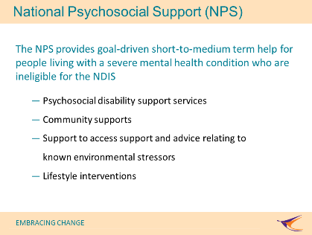  11. | 37 – 41  (4 mins) | The National Psychosocial Support (NPS) Measure  Even though 64,000 people living with psychosocial disability (mental health challenges) will be able to get NDIS funding, there are many other people living with mental health challenges and /or psychosocial disability that also need access to supports and services. State and Territories fund some mental health programs (for example, the Housing and Accommodation Support Initiative (HASI) and Community Living Supports (CLS) program in NSW. MORE ACRONYMS FOR THE LIST.  Primary Health Networks (PHNs) are funding community organisations to provide new program called the NPS service (the government uses the word ‘measure’ but this can confuse people). NPS services can help people living with mental health challenges who are ineligible, or do not want to apply, for NDIS funded supports and services.  The NPS provides goal-driven short-to-medium term help for people living with a severe mental health condition who are ineligible for the NDIS.  This includes:  - Psychosocial disability support services (including peer support, daily living support, social skills training and social participation support)  - Community supports (including peer support and social participation support)  - Support to access support and advice relating to known environmental stressors  - Lifestyle interventions (e.g., nutrition, sleep, exercise, meaningful social connections).  Ask and explore ‘Do you know who the NPS service in your area is?’. | Butchers Paper – Acronyms  Markers
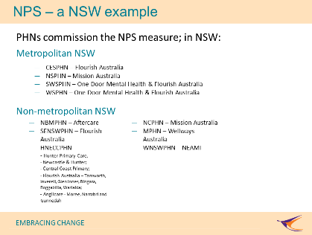  12. | 41 – 45  (4 mins) | NPS – a NSW example (consider changing this slide if delivering the topic outside of NSW)  Ask if anyone wants to add additional things happening in the mental health reform environment that they, or others, may want or need to learn more about to the ‘Changes’ list on Butcher’s paper?  Some examples of responses would be as those in slide 9 (Activity 2 – Changes) and also anything related to PHNs, NPS, etc. | Butchers Paper – Changes  Markers
13.  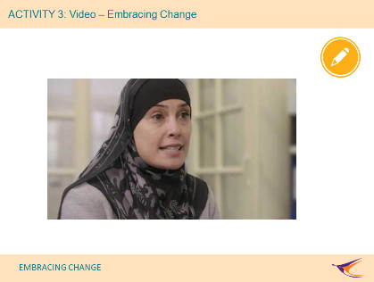 | 45 - 55 – min  (10 min) | ACTIVITY 3: Video – Show and Discuss Video  For discussion: How are the experiences of Community Workers and other supporters in this video related to gaining a greater awareness of new approaches and practices in the mental health, NDIS and ILC environment?  Note: The end of the video will prompt for:  - Who is my local PHN?  - Who my local LAC (the topic will not have named these but aim to leave people wanting to learn more about who LAC/s and NPS providers are)?  The ‘Supporting Community Connection’ Good Practice Guide has a list of the 31 PHNs nationally and NSW examples of LAC and NPS organisations. To deliver this topic outside of NSW you will want to know what organisations provide LAC and NPS services in your area OR perhaps be prepared to role model finding this out.  It may be challenging to initiate conversation about the topic and video. People are often reluctant to talks about things that are not informed about.  ‘Embracing Change’ and the reform environment is a challenging topic. Instead, you might consider discussing how challenging change can be and discuss these five things people can do to embrace change.  - Slow down – change is stressful and should be handled with care  - Prioritize – what is important for you to live a fulfilling life?  - Say no – don’t over-estimate what you are able to do  - Accept your best – know that your best will vary at different times  - Stay neutral - a negative perspective sucks energy you will need to use to embrace change and make it a constructive part of who you are becoming. | Video embedded in PPT  Back-up internet access to videos (MHCC webpage)
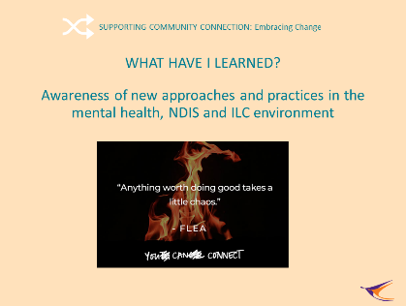  14. | 50 – 59 min  (9 min) | What have I learned?  Revisit whether the learning outcome for this module has been achieved: Awareness of new approaches and practices in the mental health, NDIS and ILC environment (and also see slide 4).  Emphasise that what we were aiming for was awareness and not a complete understanding. It will take time for us all to understand the changes that are happening.  Remind learners that we started off by exploring their knowledge of the ILC part of the NDIS. We moved on to discuss a range of changes underway:  - Local Area Coordination (LAC)  - Local Area Coordinators (LACs  - The Psychosocial Stream of the NDIS  - NDIS Recovery Coaches & Community Connectors  - Primary Health Networks (PHNs), and  - The National Psychosocial Support (NPS) service funded by PHNs.  Revisit Butcher’s Paper for: Acronyms. Say that we have learned Many. You may want to help others learn them but always try to use full names at the same time.  The NDIS ILC. Emphasise that there is a lot more to the ILC part of the NDIS then what we covered in this topic. Learning Expectations. Have people had their learning expectations for the topic met? Do they think they know more now about changes then when they arrived? Are they inspired to learn more about the changes and to also help others to learn about them? | Butchers Paper – Acronyms  Markers  Butchers Paper – The NDIS ILC  Butchers Paper – Learning Expectations
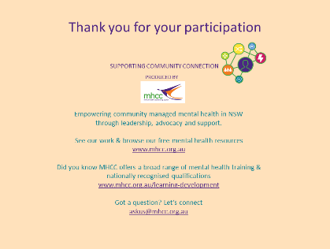  15. | 59 – 60 mins  1 min) | Concluding slide  Acknowledge MHCC’s development of the learning resource and encourage others to learn more about who MHCC is and what they do:  - Peak body for the community managed mental health sector in NSW  - Registered training organisation.

