MHCC NDIS ILC ‘Supporting Community Connection’ CEEP Project - Facilitator/Trainer Guide:
KEY TOPIC 2 – COMMUNITY INCLUSION

Slide/s | Time | Key message/s | Resource/s
Prepare four labelled Butcher Paper sheets: Rich and Fulfilling Life, Other Expectations and Practising Helping.
Familiarise yourself with, and be prepared to speak about, the MHCC reimagine.today video: ‘What does psychosocial disability mean to you’?: https://reimagine.today/step-1/what-does-psychosocial-disability-mean-to-you/ This short video has people with lived experience describing what psychosocial disability means to them. While this key topic does not spend a lot of time exploring ‘What is psychosocial disability?’ we want to encourage people to learn more about it. The topic encourages an understanding that psychosocial disability is about social and economic exclusion (not illness and symptoms).
1.  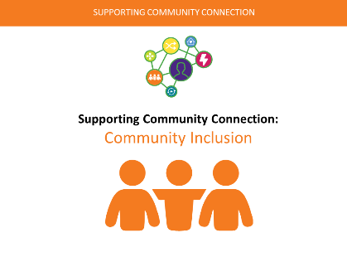 | 0 – 1 min  (1 min) | Welcome, acknowledgement/s, etc.  For the next hour we will be thinking and learning about ‘Community Inclusion’ and the importance of increasing access to community and mainstream and services for people living with mental health challenges.  Briefly explain that mainstream and community services are and that they are available for all Australians.  What are community and mainstream services?  - Mainstream services are non-disability specific services and organisations, e.g., health, mental health, education, employment, justice, housing and child protection services.  - Community services are activities not supplied by government groups, available to everyone in the community, e.g., arts & leisure groups, sports and recreational activities, etc.  When people are denied access to community and mainstream services this can be discrimination. Lack of community inclusion can result in people living with mental health challenges developing psychosocial disability.  Access to mainstream and community services helps all people to have a more fulfilling life and you can learn more about this in Key Topic 3 - ‘Supports and Services’. | PPT in all sections as in the slide column  PPT handout at 3 slides per page and note taking lines.
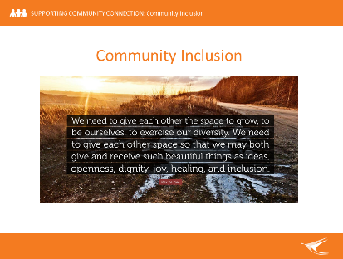  2. | 1 – 2 min  (1 min) | Reflection  Inspiring quote – present and briefly discuss. Link to notions of living a fulfilling life and the importance of supportive and inclusive environments in recovery.  In the ideal world, Community Workers and others could:  - Provide hope that living a meaningful and fulfilling life is possible  - create supportive environments that enable people to thrive.  Working in mental health is all about working with the person. It’s about people connecting with other people. You, the person, are the tool most useful to people living with mental health conditions.
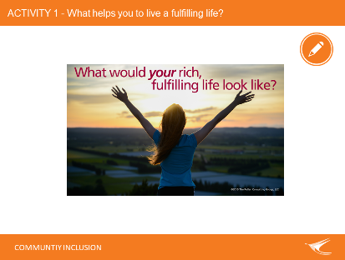  3. | 2 – 7 min  (5 min) | Activity 1 – Explore question.  Ask ‘For you, what would it mean to live a fulfilling life? Please pause and reflect, what would it look like? What would it feel like? How would you spend your time? What is important to you? What is your life rich in? Write down everything that comes to your mind.’  Document on Butchers Paper a few people’s responses that relate to ‘supportive people/environments’. Name/reframe these as ‘supportive people/environments’. | Butchers Paper - Rich and Fulfilling Life  Markers  Blu Tac
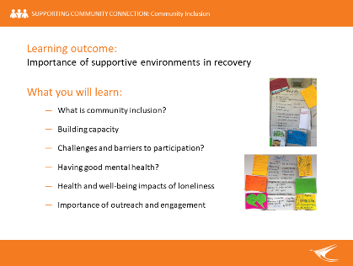  4. | 7 – 10 min  (2 min) | Introduce learning key topic and learning outcome.  Briefly reference what you will learn - the importance of supportive environments in recovery - and then ask if people have other expectations of this session.  Document other expectations on Butchers Paper (this, along with the learning outcome, will be revisited at the end of the topic). | Butchers Paper – Other Expectations  Markers
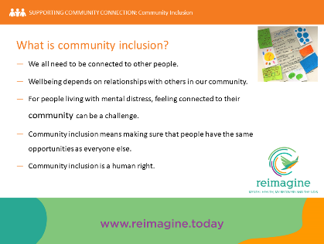  5. | 10 – 14 min  (4 min) | What is community inclusion?  Explain that we all have a role to play in supporting the community inclusion of people living with mental health challenges with, or at risk to develop, psychosocial disability.  Briefly explore what community inclusion means.  - Humans are social animals. We all need to be connected with other people.  - Health, and social and emotional, wellbeing depends on relationships with others in our lives and in our community (colleagues, neighbours, teammates, shopkeepers, interest groups, etc).  - For people living with mental distress, feeling connected to their community can be a big challenge (especially when they have experienced violence, discrimination or become socially isolated).  - Community inclusion means making sure that people have the same opportunities to participate as everyone else.  - Community inclusion is a human right (people affected by mental health conditions are still too often excluded from society and this can result in psychosocial disability).  Psychosocial disability  Ask if people understand the term psychosocial disability? You may also need to explain ‘what is psychosocial disability’? Psychosocial disability is about the social and economic barriers people can face when living with a mental health condition. It is used to describe the challenges, or limits, a person experiences in life that are related to their mental health condition. It sees these challenges and limits, or impairments, as disabilities that can affect a person’s ability to participate fully in life. This definition is from MHCC’s https://reimagine.today/ NDIS and MH e-resource which includes a great video explaining psychosocial disability: https://reimagine.today/step-1/what-does-psychosocial-disability-mean-to-you/  Community inclusion: Emphasise that all people have a right to be included as part of their community and that this is important to all people’s health and wellbeing.  - Community is a group of people living in the same place or having a characteristic in common  - Participation is the action of taking part or becoming involved with something (e.g., an event or activity)  - Increased levels of community participation and inclusion for people living with mental health conditions will have important benefits  - Improved health and wellbeing outcomes for people and their carers (in relation to health, employment, education, income and life satisfaction outcomes, etc.)  - Decrease longer-term care and support costs, and  - Prevent psychosocial disability related to exclusion and mental distress.  Emphasise that excluding people living with mental health conditions from community activities and events is discrimination and illegal.  Emphasise that increased levels of community participation and inclusion for people living with mental distress will have important benefits and especially in preventing psychosocial disability related to mental health conditions.
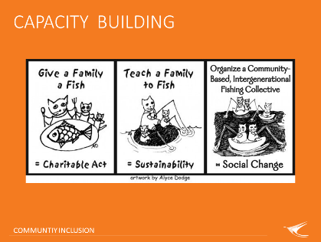  6. | 14 – 15 min  (1 min) | The notion of capacity building  Say that the parable about ‘teaching a person to fish’ instead of ‘giving a person a fish’ is well known (you might ask if people have heard of that?).  The graphic on this slide takes that idea a little further. It speaks to the above and also introduces notions of what the Information, Linkages and Capacity-building (ILC) part of the National Disability Insurance Scheme (NDIS) is about. The ILC part of the NDIS is about people undertaking community development activity to achieve individual and community capacity building and more inclusive communities for all people with, or at risk to develop a disability. This includes helping to prevent people from living with psychosocial disability.  If learners are not familiar with the ILC part of the NDIS they can be encouraged to get involved with an ILC project as one way of learning more about it.
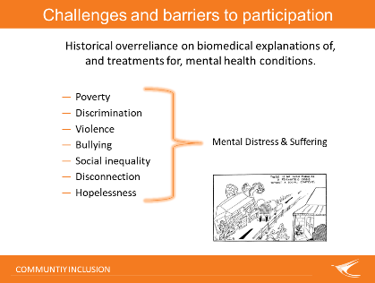  7. | 15 – 17 min  (2 min) | Challenges  Historically and even now there has been an over reliance on biomedical explanations of, and treatments for, mental health conditions. Biomedical explanations see behavioural problems as a symptom of a chemical in-balance and ‘illness’ that need to be fixed with medication and hospitalisation.  There are many other important social causes for mental distress and suffering that need to be considered and taken seriously. Some examples of these are: poverty, discrimination, violence, bullying, social inequality, disconnection and hopelessness.  State that there are no such things as a psychiatric crisis without a social context. Ask if anyone would like to add any social factors that might contribute to a psychiatric crisis to this list?  State that the World Health Organisation (WHO) recommend a social determinants and rights-based approach to working with people with mental health conditions.
8.  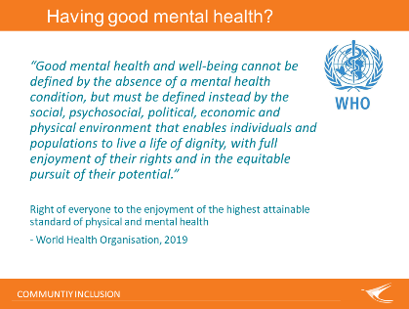 | 17 – 19 min  (2 min) | Good Mental Health  Read aloud, or ask for a volunteer to read aloud, the quote on the slide.  Introduce the ‘Right of everyone to the enjoyment of the highest attainable standard of physical and mental health’ (WHO, 2019) document. This is available on the MHCC CEEP Project website. This is about the rights of all people to have good mental and physical health, including those who live with mental health conditions.  Continue to discuss importance of the social determinants of health and a rights-based approach to supporting people living with mental health challenges.  Tell people that this is a lengthy but important read for those that want to think and learn more about mental health and community inclusion!
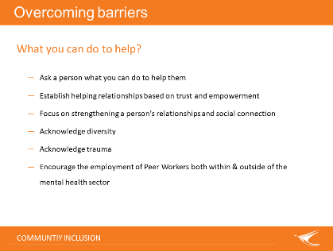  9. | 19 – 22 min  (3 min) | Overcoming barriers  Note: Do not present this slide before doing a quick brainstorm.  Brainstorm  Ask “what some things are that other people have, or could have, done to help you overcome social barriers? Write ideas down on Butcher’s Paper.  Show and review slide. Some things that people can do help are:  - Ask a person what you can do to help them (hint: it’s unlikely to be medication or hospital although some people may need and want this sometimes)  - Establish helping relationships based on trust and empowerment  - Focus on strengthening a person’s relationships and social connection  - Acknowledge diversity (in all shapes and sizes)  - Acknowledge trauma (and take leadership in creating healing environments)  - Encourage the employment of Peer Workers (i.e., people with a lived experience of a mental health condition and recovery) both within and outside of the mental sector  - Ask if there are other things that people can think of to help?
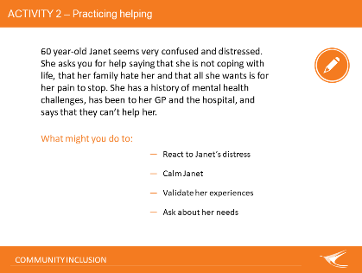  10. | 22 – 32 min  (10 min) | Activity 2 - Question  Ask for a volunteer to read out Janet’s story. Ask people to form small groups and explore ‘What they might do to:  - React to Janet’s distress  - Calm Janet  - Validate her experiences  - Ask about her needs’.  Explore some responses from groups and list on Butcher’s Paper.  Explore if loneliness has arisen as a theme? Loneliness is likely to have arisen as a theme but if it has not explore if people think that Janet could be lonely? | Butchers paper – Practicing Helping  Markers  BlueTac
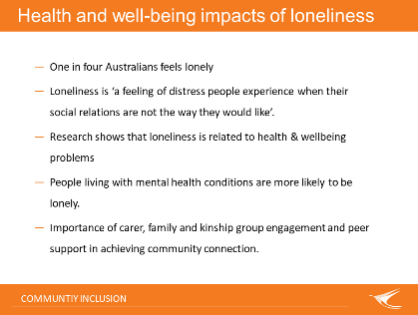  11. | 32 – 36 min  4 min | Loneliness  Understanding the health and social wellbeing impacts of loneliness is increasingly important.  Explain that you can be surrounded by people and still feel lonely. Consider quoting Robin Williams from the 2009 movie ‘The World’s Greatest Dad’: “I used to think that the worst thing in life was to end up all alone. It’s not. …(it’s) ending up with people who make you feel all alone.”  - Loneliness is a modern pandemic. One in four Australians feels lonely (‘Australian Loneliness Report’, Australian Psychological Society/APS, 2018)  - Loneliness is defined as ‘a feeling of distress people experience when their social relations are not the way they would like’.  - Research shows that loneliness is related to health & wellbeing problems including the development of depression, stress, anxiety, etc. and increased risk factors for stroke, heart attack, cancer, etc.  - People living with mental health challenges are more likely to be lonely.  - Importance of family engagement and peer support in achieving community connection. Healthy relationships with family, friends and kinship groups are important to combat loneliness.  Note: The first three dot points summarise the 2018 APS report which applied to the whole of the Australian population. The remaining two are specific to people living with mental health challenges.  If time permits, explain that many lonely people are also vulnerable people (this is a legal term). An adult ‘vulnerable person’ is:  “… an individual aged 18 years and above who is or may be unable to take care of themselves, or is unable to protect themselves against harm or exploitation by reason of age, illness, trauma or disability, or any other reason’ (Commonwealth Department of Social Services).  Emphasise that human-rights based community inclusion practices mean that we all need to work to identify supports and services that help keep people safe and heal in the communities of their choice.
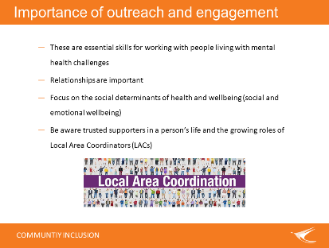  12. | 36 – 40 min  (4 min) | Outreach and engagement  It is important for Community Workers and other trusted supporters to take the time to reach and engage with people living with mental health challenges. People can have histories of trauma, or even current trauma, in their life. They may have learned to not trust others.  - Outreach & engagement is an essential skill for working with people experiencing mental distress or living with mental health challenges; especially if they also have complex health and social care needs  - Importance of relationships (across all life stages and that include relating to both community and nature)  - As discussed earlier, it is important to have a holistic focus on social and contextual determinants of health and wellbeing, and social and emotional wellbeing (and to not just focus on ‘mental illness’ , ‘symptoms’ and perceived/actual need for ‘treatment’).  - Role of NDIS Information, Linkages and Capacity-building (ILC) Local Area Coordination/Coordinators (LAC/s) and other trusted supporters  Explain that Local Area Coordinators (LACs), are a very important part of achieving community inclusion for more people living with disability, including people with disability and other and diversity. LACs have been introduced by the NDIS to help people, whether they have an NDIS package or not, to access community and mainstream supports and services.  Emphasise that everyone working in services and living in the community, whether paid or unpaid ‘supporters’, has an important role to play in the outreach to and engagement with vulnerable people and others during vulnerable times.
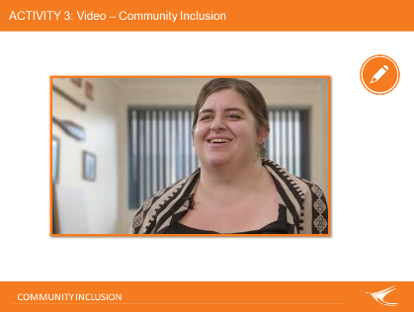  13. | 40 – 50 min  (10 min) | Activity 3  Show and discuss video (about 5 minutes). For discussion (about 5 minutes): How are the experiences of Community Workers and others in this video related to the importance of people having access to supportive environments within the communities of their choice? | Speakers (as required)  Video embedded in PPT  Back-up internet access to videos (MHCC webpage)
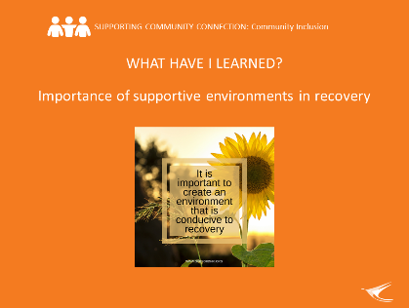  14. | 50 – 59 min (9 min) | What have we learned?  Revisit whether the learning outcome for this key topic has been achieved: understanding the importance of supportive environments in recovery (and also see slide 4).  Remind learners that we started off by exploring what it might mean to live a fulfilling life. Revisit the ‘supportive people/environments’ identified that were put on Butchers Paper earlier.  Explore if the learning content supported achieving the learning outcome and other learning module expectations of this session that were put on Butchers Paper earlier. | Revisit Butchers Paper - Other Expectations from beginning of the topic.  Revisit Butchers Paper – Rich and Fulfilling Life from beginning of the topic.
15.  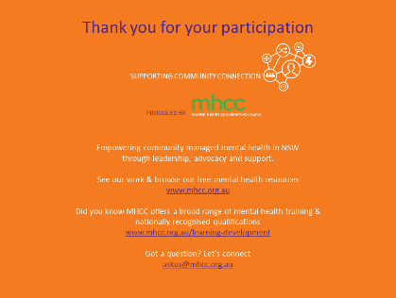 | 59-60 mins | Concluding slide.  Acknowledge MHCC’s development of the learning resource and encourage others to learn more about who MHCC is and what they do:  - Peak body for the community managed mental health sector in NSW  - Registered training organisation.

